The UM-NetHope Internship Program

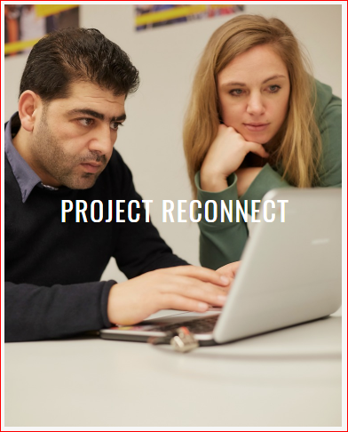
Figure 1 – NetHope Project Reconnect
The Problem?
- Students want front-line internship programs that are relevant to the issues and careers in which they have an interest.
- The humanitarian sector has supported interns in program areas, such as public health, but technology interns are rare.
- With persistent underfunding of IT in most nonprofit organizations and the coming revolution of rethinking most business as digital enterprises, the time is ripe for creating a feeder system of IT talent for nonprofit work.
- Technology corporations want graduates who can deal with chaotic, uncertain situations
The What & How
- Phase 1 – proof-of-concept phase in 2017, placing 3-5 UMSI students at NetHope member organizations.
- Phase 2 – scale-up the program at UMSI in winter 2018.
- Phase 3 – organize and pilot a placement program for matching UMSI graduates with nonprofit sector jobs
- Phase 4 – expand the program to other University of Michigan schools, especially engineering and computer science.
- Phase 5 – expand to additional universities

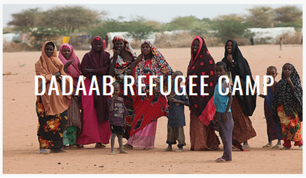
Figure 2 - NetHope Connectivity Project
Benefits?
- Practical educational experience for students in nonprofit IT organizations
- The value-add of information savvy students for NGO projects and fieldwork
- The placement of the next cadre of information technology graduates in the nonprofit sector
- The value proposition for tech company sponsors includes:
  - Help develop the next generation of leadership who can adapt to disruptions in developing countries
  - Students may work on NGO IT projects focused on a given tech platform
  - Students do a “two-for” tour: one semester in field and one at tech co.
  - Cadre of well-balanced, experienced students for recruiting
  - Opportunity for a UMSI-NetHope co-branded intern program
  - Enhance a CSR program with employee-student “buddy system” field assignments

How to get involved?
- Sign up with the Engaged Learning Center to express interest in this internship program
- Contact Ed Happ at ehapp@umich.edu or Kelly Kowatch at kkowatch@umich.edu for more details

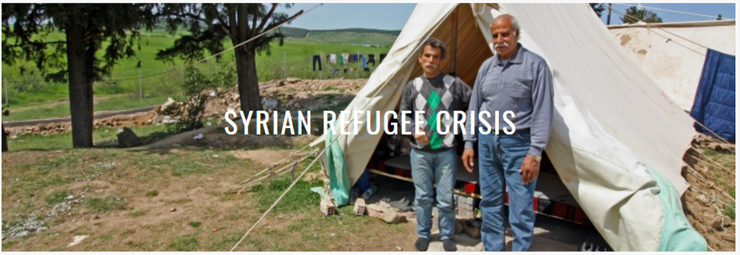
Figure 3 - NetHope Connectivity Project for Refugees

Coming in 2018…

Figure 4 - NetHope Connectivity Program

--Page intentionally left blank--

